**ST10358622**

**NETSHIVHULANA ZWAVHUDI**

**PROG6212 POE PART1**

**Documentation**

**Design choice**

The system is designed with the user in mind, providing an intuitive interface for lecturers, program coordinators, and academic managers where lectures secure login to submit claims, Ability to upload supporting documents ,Real-time tracking of claim status and program coordinators and academic managers secure login for program coordinators and academic managers Ability to view and verify submitted claims , Option to approve, reject, or request additional information

**The structure of database**

The structure of my database will have eight(8) tables which each table will also store its attributes the first one is lecturer will store attributes which are lecturer id which is the primary key ,email, name and surname, the second one is supporting documents which will store document Id, claim id and uploaded time the third one Is module which will store the module Id, module name and program Id and the fourth one is approve table which will have the attributes that are approval Id and the status name and fifth table is claim which will have the attributes which are claim Id, claim date, lecturer Id, total hours worked, amount status, submit date and the sixth table is academic manager which will store manager id, last name ,first name and the contact information and seventh table is programmer coordinator which will store coordinator id, first name, last name

**Layout of the GUI**

Firstly, you will write the module name on the module name button and /write the claim amount you want to claim and the supporting documents that they will be needed such as ID and then you can browse or submit and after submitting programmer coordinator and academic managers can then verify and approve your claims lecturers can also tracks their claims after submitting their supporting documents

**UML Diagram**

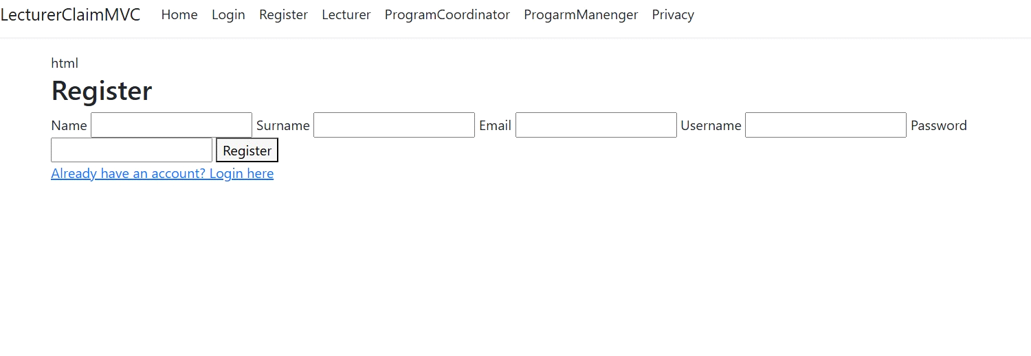

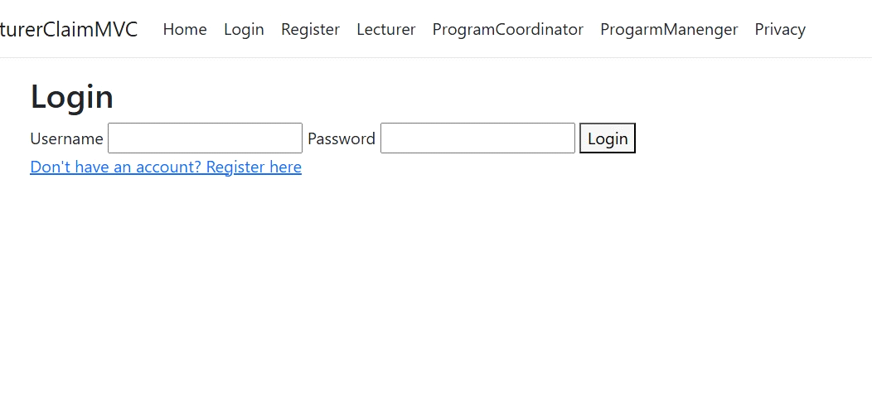

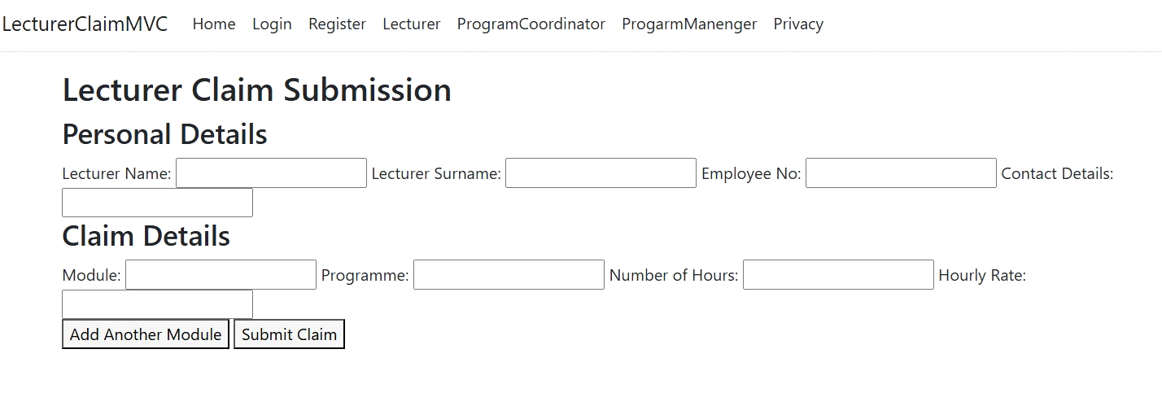

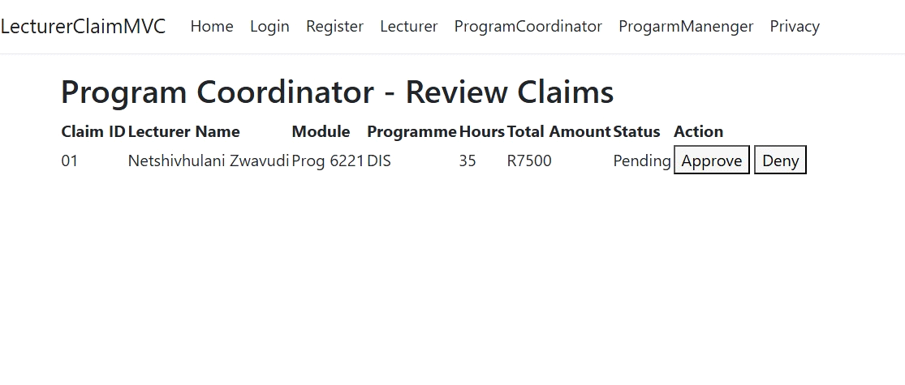

**PROJECT PLAN**

* **Project Overview**

**Name: Contract claim Monthly System**

* **Project Description**

A system designed with the user mind, providing an intuitive interface for lecturers program coordinators and academic managers where lecturer secure login to submit claims, ability to upload supporting documents, real time tracking of claims status and program coordinator and academic managers secure login for program coordinators and academic managers ability to view and verify submitted claims, options to approve, reject or request addition information

**1.3**

**Project Objectives**

**Objectives:**

1.user friendly interface

2.clear visibility into claim details and status

3.Automate claim submission and tracking

* **Project Scope**

In scope

- User friendly interface for claim submission and tracking and tracking

- Automated workflows for claims processing and approval

- integrated with existing contact management and financial system

**2. Functional requirements**

Claim submission and tracking

Claim processing and approval

Claim status update and notification

**3.user roles and responsibilities**

Contract managers

Claims managers

Financial Managers

**Out of scope**

Change to existing contract management and financial system

Implementation of new claim policies or procedures

Customization of the system

Ongoing system maintenance and support

* **deliverables**

1.System deliverables

2.functional deliverables

3.data deliverables

* **Assumption and Constraints**

**Assumption**

Availability of existing claim data and system documentation

Cooperation and input from stakeholders and subject matter experts

**Constraints**

Access to necessary technical resources and infrastructure

Timely decision making and approval processes

* **Project Organization**

2.1 Stakeholders

Stakeholders:

  1 [contract managers]

  2 [Claims managers]

  3 [Financial Managers]

**2.2 Project Team**

**Project Manager: [Zwavhudi]**

**Team Members:**

  1 [business analyst] - [Thando]

  2 [System analyst] - [Kaylen]

  3 [development team] - [Yoeme]

**2.3 Roles and Responsibilities**

**Roles and Responsibilities:**

[contract manager]: [responsible for managing contracts and ensuring compliance]

                                     [review and approves claims for validity]

                                     [ensures accurate and timely claim submission]

   [claim manager]: [responsible for managing and processing claims]

                                 [review and approve claims for validity and accuracy]

                                 [provide guidance and support to claim]

   [Financial manager]: [review and approves claims for financial accuracy]

                                       [provide financial guidance and support]

                                       [responsible for managing and processing claim]

**3. Project Phases and Milestones**

**3.1 Initiation Phase**

**- Tasks:**

**- Define project goals and objectives**

**- Identify stakeholders**

**- Develop project charter**

**- Milestones:**

**- Project charter approval**

**3.2 Planning Phase**

**- Tasks:**

- Develop project plan

  - Define project scope

  - Create work breakdown structure (WBS)

  - Develop schedule and budget

  - Identify risks and create a risk management plan

- Milestones:

  - Project plan approval

  - Schedule and budget approval

**3.3 Execution Phase**

**- Tasks:**

- Develop system architecture and design

  - Coding and unit testing

  - System integration

  - User training

- Milestones:

  - System architecture approval

- Code complete

  - System integration complete

3.4 Monitoring and Controlling Phase

- Tasks:

  - Track project progress

  - Perform quality assurance

  - Manage changes

  - Mitigate risks

- Milestones:

  - Regular status reports

  - Quality audits

 3.5 Closure Phase

- Tasks:

  - Conduct user acceptance testing (UAT)

  - Finalize documentation

  - Release and deployment

  - Conduct project review

- Milestones:

  - UAT sign-off

  - Project closure report

4. Project Schedule

4.1 Gantt Chart

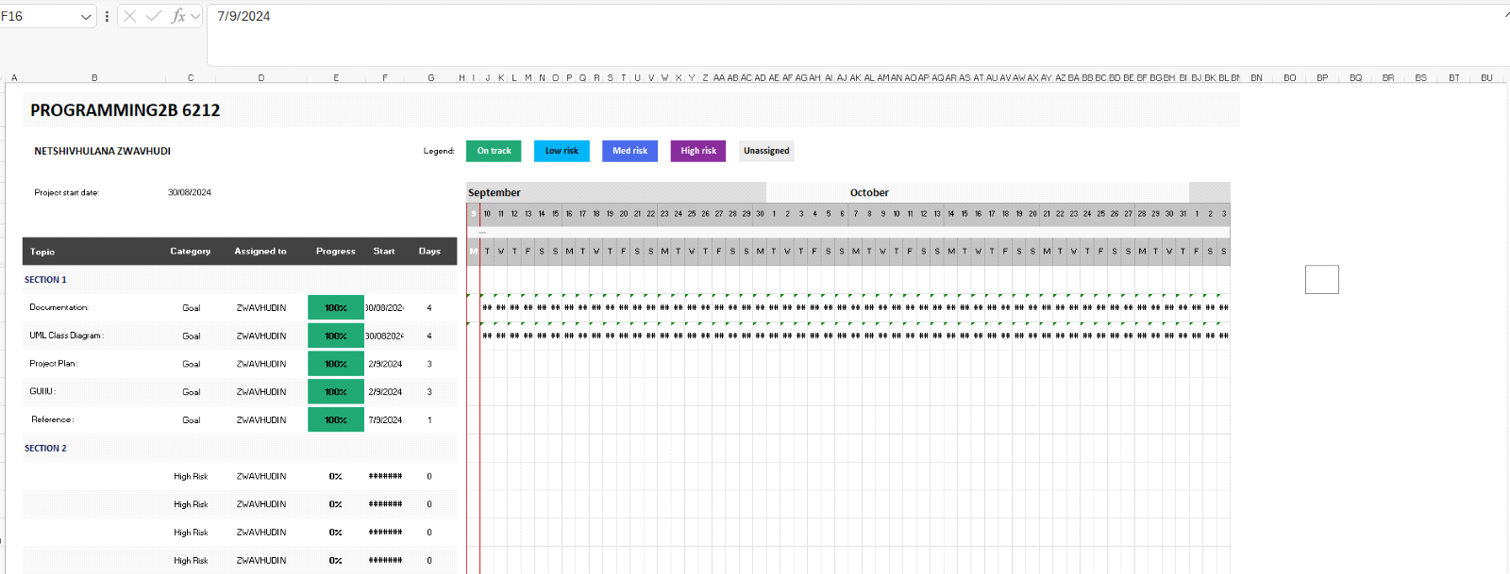

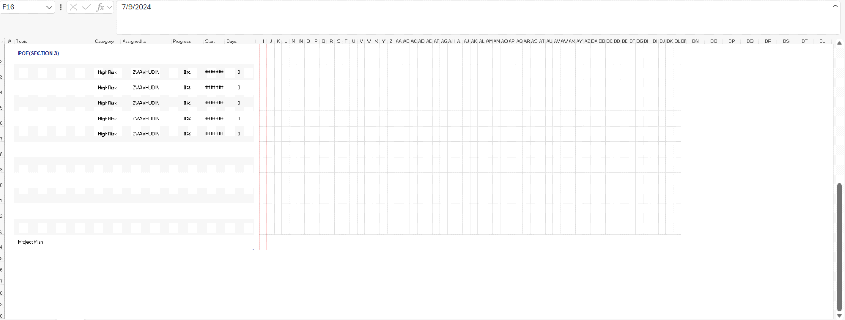

**4.2 Key Dates**

**-** Start Date: [30/08/2024]

- End Date: [07/09/2024]

5. Budget and Resources

 5.1 Budget

- Estimated Budget: [Total budget]

  - [Cost category 1]: [Amount]

  - [Cost category 2]: [Amount]

  - [Cost category 3]: [Amount]

5.2 Resource Allocation

- Resources Required:

  - [Resource 1]: [Quantity]

  - [Resource 2]: [Quantity]

  - [Resource 3]: [Quantity]

6. Risk Management

6.1 Risk Identification

- Risks:

  - [Risk 1]

  - [Risk 2]

  - [Risk 3]

 6.2 Risk Mitigation Plan

- Mitigation Strategies:

  - [Risk 1]: [Strategy]

  - [Risk 2]: [Strategy]

  - [Risk 3]: [Strategy]

7. Communication Plan

7.1 Communication Methods

- Methods:

  - Meetings

  - Email updates

  - Status reports

7.2 Frequency

- Frequency:

  - Weekly status meetings

  - Monthly progress reports

8. Quality Management Plan

8.1 Quality Objectives

- Objectives:

  - Ensure system meets requirements

  - Maintain high code quality

8.2 Quality Assurance

- QA Activities:

  - Code reviews

  - Testing (unit, integration, system)

8.3 Quality Control

- **QC Activities:

  - Defect tracking

  - Performance testing

9. Change Management Plan

9.1 Change Request Process

- Process:

  - Submit change request

  - Review and approve change request

  - Implement change

  - Update project plan

9.2 Change Log

- Change Log: [Attach or provide link to change log]

10. Project Closure

 10.1 Final Deliverables

- Deliverables:

  - Final system release

  - Documentation

 10.2 Lessons Learned

- Lessons Learned:

  - [Lesson 1]

  - [Lesson 2]

  - [Lesson 3]

10.3 Project Review

- Review Activities:

  - Conduct projects debrief

  - Archive project documents